1. List all users with the last name ‘Altman’

select \* from User  
where LastName = 'Altman';

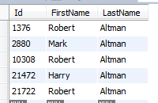 5 Rows Returned

2. List all users with the last name ‘Altman’

select \* from User  
where LastName = 'Altman';

 5 Rows Returned

… etc …